**YouTube tutorial 50 – Graphical User Interface (GUI)**

**import** javax.swing.JOptionPane;

**class** apples{

**public** **static** **void** main(String[]args){

String fn = JOptionPane.*showInputDialog*("Enter first number");

String sn = JOptionPane.*showInputDialog*("Enter second number");

**int** num1 = Integer.*parseInt*(fn);

**int** num2 = Integer.*parseInt*(sn);

**int** sum = num1 + num2;

JOptionPane.*showMessageDialog*(**null**, "The answer is " +sum, "the title", JOptionPane.*PLAIN_MESSAGE*);

}

}

**Result:**

**instances 1:**

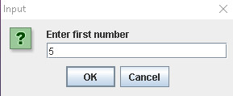

**Instance 2:**

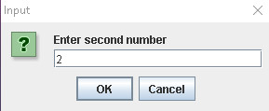

**Instance 3:**

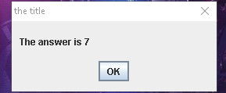

**Important notes:**

* All GUI are made from GUI components. These components are located in a built-in class.
* To import the class, type “import javax.swing.JOptionPane;
* For the “showInputDialog”, it can only take string.
* In “JOptionPane.*showMessageDialog*(**null**, "The sum is " +sum, "the title", JOptionPane.*PLAIN_MESSAGE*);” , the null gives space, and put the message in the middle.
* The third argument is the title.